Processing and Characterization of Hierarchical Surface Treatments for Ti Implants:
TiO₂ Nanotubes

Prepared by:
Alyson Michael

Faculty Advisors:
Dr. Grant Crawford
Assistant Professor, Department of Materials and Metallurgical Engineering

Dr. Michael West
Back to the Future REU Site Director

Dr. Alfred Boysen
Professor, Department of Humanities

Program Information:
National Science Foundation
Grant # 1157074

Research Experience for Undergraduates
Summer 2012

South Dakota School of Mines and Technology
501 E Saint Joseph Street
Rapid City, SD 57701

Table of Contents
Abstract 3
Introduction 4
Broader Impact 5
Experimental 5
Procedure 5
Preparation of the Polished Ti Samples 5
Preparation of the Cold Sprayed Ti Samples 6
Anodization of the Ti Surface 6
Nanotube Characterization 7
Results and Discussion 7
Image Analysis 7
Effect of pH on Nanotube Dimensions 9
Effect of Anodization Time on Nanotube Dimensions 12
Formation of TiO₂ Nanotubes on the Cold Sprayed Surface 15
Conclusions 17
Acknowledgments 17
References 18

Abstract

The formation of a hierarchical surface on titanium with both microscale and nanoscale surface features was investigated as a means of improving orthopedic implants. Titanium oxide nanotubes were formed on a commercially pure titanium substrate by the anodic oxidation of polished commercially pure titanium in an electrolyte solution consisting of 1 M sulfuric acid, 0.2 M citric acid, and 0.1 M NaF. The pH of the electrolyte solution was buffered with sodium hydroxide to a pH of 3.5, 4.0, or 4.5. A constant potential difference of 20 V was applied across the cell for 30 min, 1 h, or 2 h. With pH variations 3.5 to 4.5, the inner diameter, wall thickness, and length of the nanotubes varied from 82.2 to 77.2 nm, 27.7 to 33 nm, and 670 to 1350 nm, respectively. With anodization time variations of 30 min to 2 h, the inner diameter, wall thickness, and length of the nanotubes varied from 80.4 to 78, 26.4 to 28.3, and 540 to 872 nm, respectively. A hierarchical surface with both microscale and nanoscale features was formed by the anodic oxidation of a commercially pure titanium substrate that had been coated with 40 μm particles through cold spray technology.

Introduction

Titanium and its alloys are used in orthopedic implants because of their biocompatibility, high strength to weight ratio, and resistance to corrosion^{5, 7, 11}. Orthopedic implants fail when stress shielding occurs. This happens when the bone does not adhere to the surface of the implant and the implant supports most of the load that would normally be supported by the bone or a fibrous sack forms around the implant as a part of the immune response. The bone resorbs because it is not being stressed which ultimately leads to implant failure and must be replacement^{3, 10}. One way orthopedic implants can be made more successful is for the surface of the implant to be roughened in order to increase osteoblast adhesion and osseointegration^{1, 6, 9, 10}. Osteoblasts are micron sized and so it makes sense that when cells are cultured on surfaces with microscale topography enhanced cell proliferation, greater cell adhesion, and an increase in the deposition of calcium containing minerals and observed². One of the most critical aspects of microscale surface features 200-250 nm in size is the ability of the bone cells to mechanically interlock with the implant surface. Nanoscale topographies seem promising for improving orthopedic implants because bone cells interact with each other on the nanoscale and important cell components are nanoscale in size. Surfaces with nanoscale topographies can stimulate the organization of receptors in the cell membrane which has an effect on intercellular signaling^{2,7}. It is also believed that nanoscale surface feature help to guide the formation of the cytoskeleton and can increase cell attachment and fibroblast differentiation^{2,5,7}. It has been shown that nanoscale surface features can be created on a Ti substrate through the anodic oxidation of the oxide layer to for TiO₂ nanotubes^{4,5, 8}. The dimensions of theses nanotubes can be manipulated by varying the processing conditions^{4,5,8,11}. In the hopes of creating a surface that combines the benefits exhibited by microscale and nanoscale surface features, a hierarchical surface with both microscale and nanoscale topographies will be created through the anodic oxidation of a Ti substrate that has been coated with 40 μm Ti particles.

Broader Impact

The human life expectancy is increasing, and people have the desire to remain active well into their golden years. This has increased the demand for orthopedic implants with longer lifetimes; however, the average lifespan of a Ti implant is 10-15 years^{2, 10, 11}. Failed implants cause pain and can severely impact the mobility of the recipient. That means that a 55 year old who gets a knee replacement will likely have to undergo the same surgery before he or she turns 70 or face decreased mobility. Research needs to be done to improve the success and longevity of orthopedic implants in order to meet the needs of people who expect to continue to be active into their 70’s. The longevity and success of orthopedic implants can be improved by modifying the surface of the implant to increase interaction at the bone-implant interface so as to improve osseointegration.

Experimental

Procedure

Preparation of the Polished Ti Samples
A thin (0.74 mm) Ti sheet (+99.4% purity, Alfa Aesar) was cut into squares with a surface area of approximately 2.25 cm² with a diamond saw (Buehler). A 1.19 mm hole was drilled into the samples with a size 1 centerdrill bit. The Ti samples were then polished on polishing tables (MetaServ250, Buehler) using 600 and 1200 grit silicon carbide paper (Leco) and then brought to a mirror shine using 1μm and 0.3 μm alumina polishing suspension on a felt pad (Leco).

Preparation of the Cold Sprayed Ti Samples
A section of Ti sheet was roughened using a polishing table with 600 grit silicon carbide paper. The sample was then cold sprayed with 40 μm Ti particles.

Anodization of the Ti Surface
The electrolyte solution was made to be 1 M H₂SO₄ (Fischer Scientific), 0.2 M citric acid (Sigma-Aldrich), 0.1 M NaF (Fischer Scientific). The solution was then buffered to a pH of 3.5, 4.0, or 4.5 with solid NaOH pellets (Fischer Scientific) and transferred to an electrochemical cell containing a Pt mesh cathode (Princeton Applied Research). The pH of the electrolyte solution was measured using a microprocessor pH meter (Omega PHB-212). A constant potential difference of 20 V was applied between the Pt cathode and the Ti sample to be anodized for 30 min, 1 h, or 2 h by one of two DC power supplies (Agilent E3612A or Sorensen LT 30-3). The current through the electrochemical cell was monitored and recorded using a multimeter (Keithley 2100 6 ½ digit). A chemical reaction was evidenced by the evolution of H₂ gas. The Ti sample was removed from the anodization vessel, rinsed with water and left to dry. The original anodization vessel, an electrochemical cell for flat specimens (Princeton Applied Research), failed to produce nanotubes (Figure 1). This was perhaps due to insufficient current density on the anodization surface. Nanotubes were successfully produced when the anodization vessel was changed to a 250 mL plastic beaker (Figure 1). When using the plastic beaker 15.24 cm of thin Ti wire (0.25 mm, 99.7% purity, Sigma-Aldrich) were cut and looped through the hole in order to hold the Ti sample to be anodized in the electrolyte solution.

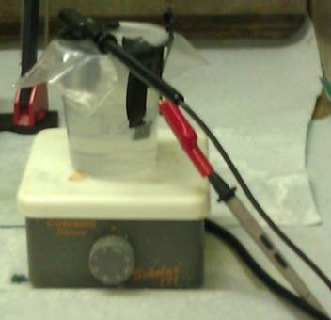
Nanotube Characterization
a)
b)
Figure 1: a) The original electrochemical cell. b) The 250 mL plastic beaker during anodization.
The presence of nanotubes on the anodized surface was verified using FESEM (Supra 40 VP, Zeiss). Top down images of the samples were taken in order to determine the inner diameter and wall thickness of the nanotubes. Cross sectional images were obtained by cutting off a thin strip of the sample with the diamond saw and then bending the thin strip back on itself in order to fracture the nanotube coating. The cross sectional images were used to determine the length of the nanotubes. All nanotube measurements were made through image analysis using ImageJ (US National Institutes of Health). The nanotube measurements were analyzed using ANOVA testing and Student’s T-Tests in order to assess the variance of the measurements, their significance, and their source.

Results and Discussion

Image Analysis
Figure 2 shows a top down image of typical TiO₂ nanotubes. The walls of the nanotubes are shown as the lighter gray rings. The inner pores of the nanotubes are represented by the darker circles within the rings. The darker spaces on the outside of the nanotube walls represent the voids between the nanotubes. The nanotubes shown in Figure 2 have an average internal diameter of 78.4 nm, and an average wall thickness of 28.5 nm.
Figure 2: A top down view of TiO₂ nanotubes formed in an electrolyte solution with a pH of 4.0 and anodized for 1 h with a potential difference of 20 V
Nanotube Inner Diameter
Nanotube Wall Thickness
Figure 3 is a cross sectional image of TiO₂ nanotubes taken of a fractured nanotube coating. When the coating fractures it lifts off of the Ti substrate, sometimes creating tent shaped formations. The lightly shaded area on the left hand side of the image correlates with the top of the nanotube coating. The solid darker area on the right hand side of the image indicates a gap underneath the coating due to the fracture pattern. The textured medium gray section located in the center of the image represents a cross section of the TiO₂ nanotube coating. The nanotubes, being made of TiO₂, are ceramic and are therefore quite brittle and individual fractured nanotubes can be seen in this cross sectional images.

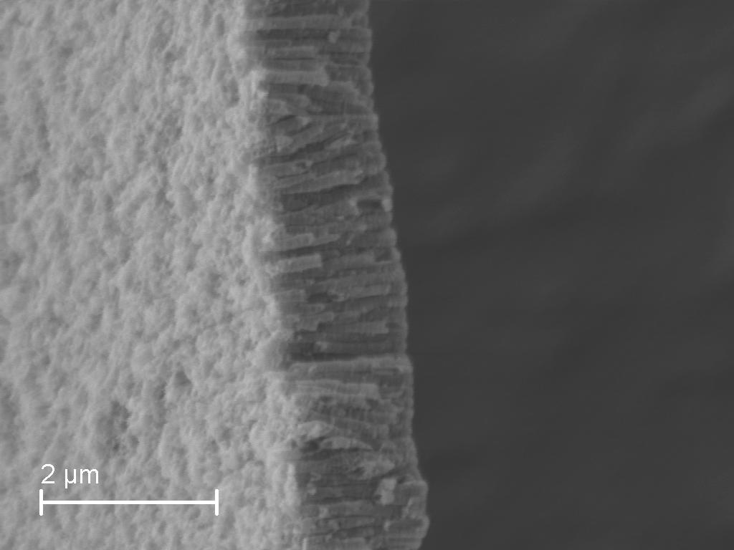
Effect of pH on Nanotube Dimensions
Nanotube Length
Top of Nanotube Coating
Figure 3: Cross sectional image of nanotubes formed in an electrolyte solution with a pH of 4.5 and anodized for 1 h with a potential difference of 20 V
Figure 4 shows a graph of the mean inner diameter of the nanotubes formed in an electrolyte solution with a pH of 3.5, 4.0, and 4.5. It was found that the nanotubes formed in an electrolyte solution had smaller inner diameters than those formed at 3.5 and 4.0. This is contrary to the trend observed in the literature in which no correlation between electrolyte pH and nanotube diameter⁴ Statistical analysis showed no significant difference in the average diameter of nanotubes formed in an electrolyte with at pH of 4.0 and a pH of 3.5.. A larger data set would be required to assess the validity of the decrease in the internal diameter seen.

pH | Internal Diameter (nm) | Standard Error
3.50 | 82.2 | 0.8
4.00 | 78.4 | 0.8
4.50 | 77.2 | 0.8
Figure 4: Effect of pH on nanotube internal diameter anodized for 1 h with a potential differnce of 20 V.
Figure 5 illustrates the effect of electrolyte pH on the mean thickness of the nanotube walls for nanotubes formed during 1 h of anodization with a potential difference of 20 V applied across electrolyte solutions with a pH of 3.5, 4.0, and 4.5 The pH of the electrolyte solution had a small effect on the thickness of the nanotube walls. Statistical analysis indicated that there was no significant difference between the wall thicknesses of nanotubes formed in an electrolyte solution with a pH of 3.5 and those formed in an electrolyte solution with a pH of 4.0. There was, however, a significant increase in the wall thickness of the nanotubes formed in an electrolyte solution with a pH of 4.5 as compared to the others. This is also contrary to the findings of Crawford and Chawla who did not note an increase in nanotube wall thickness⁴. The wall thickness measurement was one of the more subjective measurements made. The accuracy could be improved by making measurements using micrographs taken at a higher magnification than 74 kx and obtaining a larger data set.

pH | Wall Thickness (nm) | Standard Error
3.5 | 27.7 | 0.4
4 | 28.5 | 0.5
4.5 | 33 | 0.4

Figure 5: Effect of pH on nanotube wall thickness of nanotubes formed in electolyte solutions of 3.5, 4.0, and 4.5 anodized for 1 h with a potential difference of 20 V.

Figure 6 shows the variation of the length of nanotubes formed during 1 h of anodization with a constant applied potential of 20 V in electrolyte solutions with a pH of 3.5, 4.0, or 4.5. As expected the nanotubes formed in an electrolyte solution with the pH of 4.5 were longer than those formed in electrolyte solutions of lower pH⁴. However, statistical analysis showed that there was no significant difference in between the length of the nanotubes formed in an electrolyte solution of pH 3.5 and those formed in an electrolyte solution of pH 4.0. This deviation from the expected trend may be due to the nanotubes not being able to reach their equilibrium length during the standard 1 hour anodization time used during the pH trials.
Figure 6: Effect of pH on nanotube length on samples anodized for 1 h and an applid potential of 20V

pH | Length (nm) | Standard Error
3.5 | 670 | 20
4 | 670 | 20
4.5 | 1350 | 20

Effect of Anodization Time on Nanotube Dimensions
Anodization Time (h) | Inner Diameter (nm) | Standard Error
0.5 | 80.4 | 0.9
1 | 78.4 | 0.8
2 | 78 | 0.6
Figure 7 shows the variation of the inner diameter of the nanotubes formed during 30 min, 1 h, and 2 h of in and electrolyte solution with a pH of 4.0 with a constant applied potential difference of 20 V. Contrary to what would be expected according to the literature, a decrease in the inner diameter of the TiO₂ nanotubes was noted at longer anodization times. It was anticipated that the inner diameter of the TiO₂ would remain the same at all anodization times⁴. Statistical analysis indicated no significant difference between the inner diameters of the nanotubes during after 30 minutes of anodization and those formed during 1 hour of anodization; however, the nanotubes formed during 2 hours of anodization had significantly smaller inner diameters.
Figure 7: Effect of anodization time on the inner diameter of nanotubes formed in an electrolyte solution with a pH of 4.0 and a constant potential difference of 20 V.

Figure 8 shows the wall thickness of nanotubes formed during anodization times of 30 min, 1 h, and 2 h in an electrolyte solution with a pH and with a potential difference of 20 V applied across the electrochemical cell. The nanotubes formed during longer anodization times had thicker walls than those formed during shorter anodization times. Statistical analysis showed a significant difference between the lengths of the nanotubes formed during 30 minutes of anodization and those with a 1 hour anodization time. The nanotubes formed during 2 hours of anodization were not found to have a significant difference from those formed during 1 hour of anodization. The literature indicates that the thickness of the nanotubes should remain the same regardless of the duration of the anodization time⁴. This deviation from the expected trend could be explained by a small sample size and measurement inaccuracy.
Anodization Time (h) | Wall Thickness (nm) | Standard Error
0.5 | 26.4 | 0.4
1 | 27.9 | 0.4
2 | 28.3 | 0.4

Figure 8: Effect of anodization time on nanotube wall thickness for nanotubes formed in an electrolyte solution with a pH of 4.0 and a potential difference of 20 V.

Figure 9 illustrates the variation in the length of the nanotubes formed during anodization times of 30 min, 1 h, and 2 h in an electrolyte solution with a pH of 4.0 and with a potential difference of 20 V. As anticipated by the literature, the nanotubes formed during longer anodization times were longer⁴. There was no statistical significant difference between the lengths of the nanotubes formed during 30 minutes of anodization and those formed during 1 hour of anodization. This could be due to the small sample size of nine measurements. The nanotubes formed during two hours of anodization were really fragile and tended to flake off in sheets when being transferred to another room.
Table 6

Anodization Time (h) | Tube Length (nm) | Standard Error
0.5 | 540 | 70
1 | 670 | 20
2 | 872 | 30
Figure 9: Effect of anodization time on the length of nanotubes formed in an electrolyte solution with a pH of 4.0 and a potential difference of 20 V.

Formation of TiO₂ Nanotubes on the Cold Sprayed Surface
Nanotubes formed on the cold sprayed surface creating a hierarchical surface that looks promising for surface treatments for orthopedic implants. The nanotubes did not form uniformly, but processing conditions could be manipulated in order to remedy this situation. A large amount of precipitate was present on the surface of the hierarchical surface that was anodized in an electrolyte solution with at pH of 4.0. There was still precipitate present on the surface anodized in an electrolyte solution with a pH of 3.5, but it was greatly reduced from those seen with a pH of 4.0.
Figure 10: a) Microscale Surface Features of Hierarchical Surface
b) Nanoscale Surface Features of Hierarchical Surface
a)
b)

Conclusions

Titanium oxide nanotubes were formed on a commercially pure titanium substrate by the anodic oxidation of polished commercially pure titanium in an electrolyte solution consisting of 1 M sulfuric acid, 0.2 M citric acid, and 0.1 M NaF. The pH of the electrolyte solution was buffered with sodium hydroxide to a pH of 3.5, 4.0, or 4.5. A constant potential difference of 20 V was applied across the cell for 30 min, 1 h, or 2 h. With pH variations 3.5 to 4.5, the inner diameter, wall thickness, and length of the nanotubes varied from 82.2 to 77.2 nm, 27.7 to 33 nm, and 670 to 1350 nm, respectively. With anodization time variations of 30 min to 2 h, the inner diameter, wall thickness, and length of the nanotubes varied from 80.4 to 78, 26.4 to 28.3, and 540 to 872 nm, respectively. A hierarchical surface with both microscale and nanoscale features was formed by the anodic oxidation of a commercially pure titanium substrate that had been coated with 40 μm particles through cold spray technology. This hierarchical surface appears to be promising new technology for orthopedic implants, but requires biological testing.

Acknowledgments
The funding for this research came from the National Science Foundation REU grant #1157074. Thanks to advisors Dr. Grant Crawford and REU site director Dr. Michael West for their direction and guidance and to graduate student Ellen Sauter and Christi McLinn for their camaraderie in our nanotube adventures.

References
1. Anselme, K., Bigerelle, M., Noel, B., Iost, A., & Hardouin, P. (2001). Effect of grooved titanium substratum on human osteoblastic cell growth. Journal of Biomedical Materials Research, 529-540.
2. Balasundaram, G., & Webster, T. J. (2006). A perspective on nanophase materials for orthopedic implant applications. Journal of Materials Chemistry, 3737-3745.
3. Branemark, P.-I. (1983). Osseointegration and its experimental background. The Journal of Prosthetic Dentistry, 399-410.
4. Crawford, G., & Chawla, N. (2008). Porous hierarchical TiO nanostructures: Processing and microstructure relationships. Acta Materialia, 854-867.
5. Das, K., Bose, S., & Bandyopadhyay, A. (2008). TiO2 nanotubes on Ti: Infuence of nanoscale morphology on bon cell-materials interaction. Journal of Biomedical Materials Research Part A, 225-237.
6. Flemming, R., Murphy, C. J., Abrams, G. A., Goodman, S. L., & Nealey, P. F. (1999). Effects of synthetic micro- and nano-structured surfaces on cell behavior. Biomaterials, 573-588.
7. Liu, Y., Chen, W., Yunzhi, Y., Ong, J. L., Tsuru, K., Hayakawa, S., & Osaka, A. (2009). Novel fabrication of nano-rod array structures on titanium and in vitro cell responses. Journal of Materials Science: Materials in Medicine, 2735-2741.
8. Macak, J. M., Tsuchiya, H., Ghicov, A., & Schmuki, P. (2005). Dye-sensitized anodic TiO2 nanotubes. Electrochemistry Communications, 1133-1137.
9. Park, J. H., Olivares-Navarrete, R., Wasilewski, C. E., Boyan, B. D., Tannenbaum, R., & Schwartz, Z. (2012). Use of polyelectrolyte thing films to modulate Osteoblast response to microstructured titanium surfaces. Biomaterials, 5267-5277.
10. Tran, N., & Webster, T. J. (2009). Nanotechnology for bone materials. WIREs Nanomedicine and Nanobiotechnology, 336-351.
11. Variola, F., Brunski, J. B., Orsini, G., Tambasco de Oliveira, P., Wazen, R., & Nanci, A. (2011). Nanoscale surface modification of medically relevant metals: state-of-the art and perspectives. Nanoscale, 335-353.

